Accounting for non-traded crops

WITS
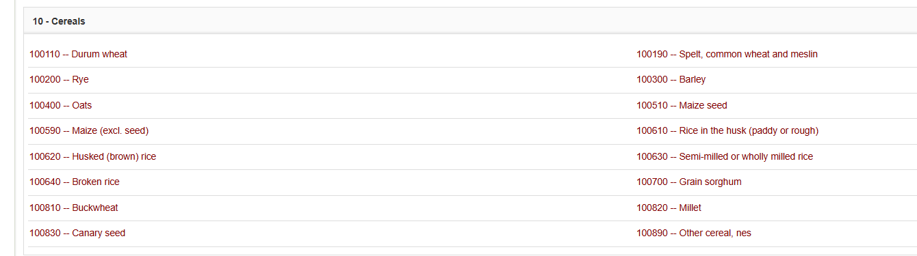

- Topalova discounts cereals and oilseeds workers (assigns tariff of 0) confounding; poorer regions produce more and affects employment through mean reversion
- With exception of cereals and oilseeds, tariffs on agricultural products were reduced sharply

IIFT-MGhosh-WTOAgriculture.pdf
- Indian gov initiated reform process in agriculture since 1994-1995
- Exceptions: wheat and rice?
- Progress of liberalisation of trade policies for agricultural products very slow in early 1990s. Exports/imports of agricultural restricted through several controls including quotas, licenses, prohibitions and minimum export prices, high tariff rates etc.
- Process of liberalisation of external trade policies for agricultural products accelerated since 1995.
- Import policies remarkably changed in April 2001. Some imports restricted or canalised in 1992 – 1997.

‘Export-Import policies from 1992 – 1997’ for selected agricultural products are summarised in Chand and Bajar (2012).
Agricultural_Trade_Liberalization_Polici.pdf: Agricultural Trade Liberalization Policies in India: Balancing Producer and Consumer Interests – Ramesh Chand and Sumedha Bajar
- External trade further liberalised with implementation of WTO Agreement on Agriculture in 1995.
- Some imports banned, restricted or canalised (importing or exporting only through agencies designated by Central Government.
- Import policy: canalised til 1999: wheat, rice, maize, rapeseed-mustard seed, soybean seed, groundnut seed (latter 4 seeds come under oilseeds).

